

# Topographical Survey – Field H 1550 (N) & (S)

Sirius Land Surveying

**Description of the works:**

To undertake a topographical survey of the surface features of the land on around Overdale including Westmount Road and adjacent fields. This will include the detailed mapping the correct depth, height and distance for roads, street furniture, drainage lines, slops/earthworks and any forest areas. The survey will start within the Overdale premises, adjacent fields before moving to Westmount Road, these are the critical areas that require surveying.

The surveyor will erect a tripod on a coordinated control point then walk around to various other control points to take a reading. There will be no intrusive works and any private land the surveyor needs to access will have prior agreement to do so. Fig. 01 displays area within the red line boundary in the field H 1550 (N) & (S) where the survey will take place.

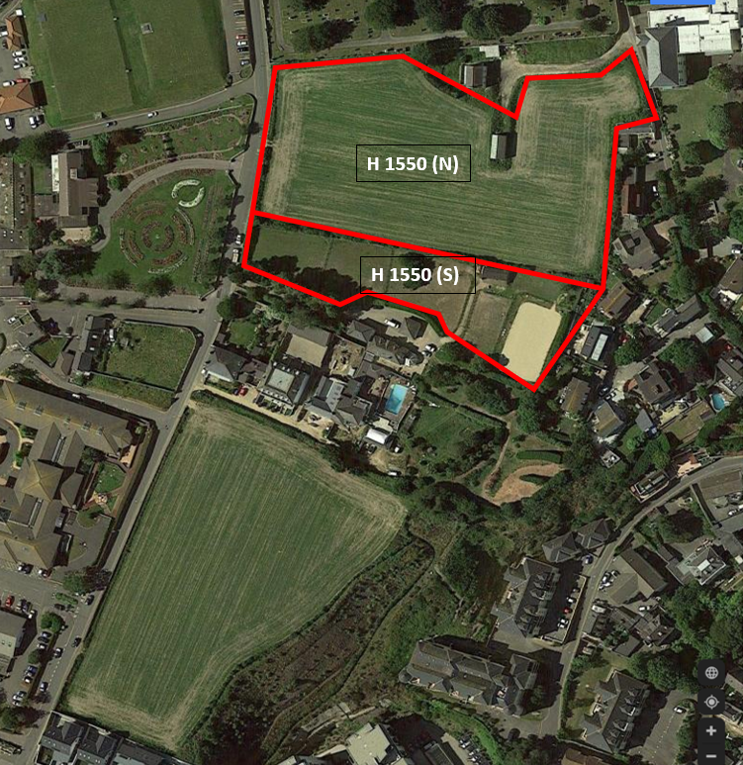All works carried out will be in accordance to Sirius Land Surveying risk assessment and method statements and under strict COVID-19 guidelines. The surveyor will be wearing 4 point PPE, hard hat, high-visibility jackets and steel toe capped boots, along with a face mask at all times. The surveyor will adhere to all social distancing measures from the public.

Fig. 01

**Number of personnel:**

One surveyor, from Sirius Land Surveying will be all that is required to conduct this survey with one instrument, a Leica TS15 3 Second, which will be positioned on a tripod at a coordinated control point. The other piece of equipment the surveyor will use is a measuring staff which he will carry round to the various control points to take a reading from the tripod.

**Duration:**

The duration of the survey in Field H 1550 (N) will take approx. 1 week.

The duration of the survey in Field H 1550 (S) will take approx. 1 week.